
FABRIC OF MEMORY
An Exhibition of Mohammed Joha Curated by Hazem Harb
January 21 – March 3
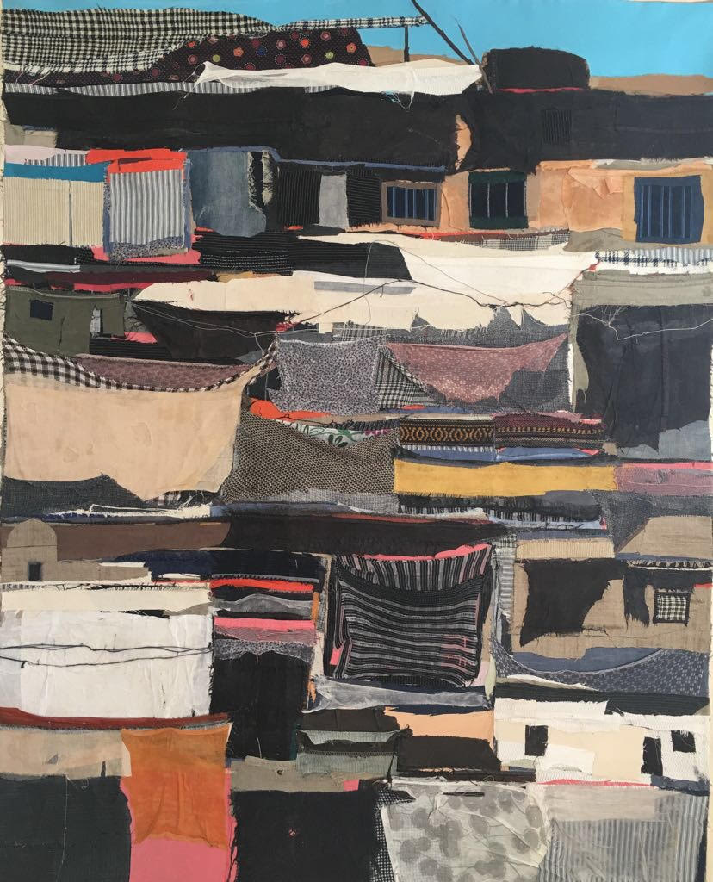
Tabari Artspace is delighted to announce its first exhibition of 2019, a show spotlighting the work of Mohammed Joha.
Fabric of Memory, which has been curated by visual artist, also of Palestinian origin, Hazem Harb, draws together a selection of works by Mohammed Joha that spans paint, collage, and installation to tackle the themes of displacement, cultural malaise, dystopia, and identity that have arisen from the Palestine-Israel conflict. Through an immersive environment and the insider’s gaze of the artist the exhibit aims to shine a light on the lesser known realities of Gaza.
Joha’s works are concerned with the Palestine of now, highlighting the limiting conditions enforced upon those that were displaced. On first impression his surrealist paintings are playful and vibrant, yet they relay deep rooted messages of despair and destruction linked to current media portrayal and the hardships of war. In addition to Joha’s paintings Harb has also selected a collection of collages to be displayed.
Fabric of Memory will be presented in Tabari Artspace’s DIFC gallery, however, Harb is set to transform the space into an environment that expands our understanding of the exhibit and the migrant experience. Alongside the selected artworks by Joha, Harb has created an immersive installation designed to create the sense of claustrophobia and chaos experienced by the Palestinians who were driven into life as refugees, stripped of their homes, belongings, and social identities at once.
“Gaza has become a space that has no routine at all: when it's war, it's difficult to call it war, and living repeatedly through such radical transformation makes it almost impossible to cope, every time again, with a profoundly altered geography.
The course of the streets, the shape of the houses, everything is different now. Here was a street surrounding a public park, and there was a hotel next to a tower, and an apartment building hosting a grocery store on its ground floor. Everything has changed!” - Mohammed Joha, Paris, 2018
Fabric of Memory is part of Tabari Artspace’s recent program dedicated to supporting and celebrating Palestinian art driven by the gallery founder, Maliha Tabari’s, passion for and understanding of the rich and vibrant art of her country. During 2018 the gallery exhibited such Palestinian creatives as hyperrealist Samah Shihadi and contemporary designers, Naqsh Collective, acting as a platform to showcase these diverse and dynamic talents to the wider world.
ABOUT MOHAMED JOHA
Mohammed Joha was born in Gaza -Palestine in 1978 and currently lives between Italy and France. He graduated in Art Education from Al-Aqsa University in Gaza in 2003. This same year he participated in a workshop residency in Darat Al Funun, Khalid Shoman Foundation in Amman-Jordan, supervised by artist Marwan Kassab Bacchi. In 2004, he was the winner of the A. M. Qattan Foundation s "Hassan Al Hourani Young Artist Award", when he was selected Artist of the Year 2004.
This allowed him to reside in the “Cité Internationale des Arts” in Paris in 2005 and 2008, where he develops and strengthens his artistic personality. Besides being selected for international workshops and residencies, he has participated in exhibitions worldwide. Joha has been working in the field of painting and has gathered a remarkable artistic experience.
He is one of the most interesting artists from Gaza-Palestine, who stands out by a very elaborate personal style of painting, a masterly combination of various artistic elements in his compositions, and most sophisticated messages. Through mixed techniques of painting, installation, together with a most spontaneous, expressive style, much of his work has explored the questions and conditions of childhood and the loss of innocence and freedom experienced by generations of children in Palestine. The overcoming of physical and psychological barriers imposed by conflict; revolutionary social and political events; resilience and identity are recurrent themes.
The closer his works are examined, the more complex they become, in texture, content, and narrative. These multilayered, transformed representations of reality leave room for imagination and interpretation, because they are inspired by universal values and reflect the memory of a collective entity, without being bound to cultural restrictions or temporary or local individualistic gestures.

ABOUT HAZEM HARB
Born in 1980 in Gaza; Palestinian artist Hazem Harb currently lives between Rome, Italy and Dubai, UAE. Harb completed his MFA at The European Institute of Design, Rome, Italy in 2008. Some of Harb’s solo shows include: ‘The Invisible Landscape & Concrete Futures’ curated by Lara Khaldi, Salsali Private Museum, Dubai, March 2015; Al Baseera, Athr Gallery, Jeddah, 2014; I can imagine you without your home, Dubai, UAE, 2012; Is this your first time in Gaza? The Mosaic Rooms, A.M. Qattan Foundation, London, UK 2010.
He has also participated in numerous international group exhibitions some of which are: Active Forms Sharjah Art Foundation 2018; El Beit, Tabari art space 2018; CHERS AMIS (DEAR FRIENDS) 2016 Centre Pompidou Museum Paris 2007; The absence of paths, Tunisian Pavilion, 57th Biennale di Venezia 2017; The armory Show, New York 2016; A View From Inside, FotoFest Houston Biennial Houston USA 2014; and Sphere 6, Galleria Continua’s Le Moulin, France 2013 and 2014; Common Grounds, Villa Stuck Museum, Munich 2015; The Written City, Brugge City Hall, Belgium 2015; Passaggio di tempo, Luigi Pigorini Museum Rome Italy 2008.
Harb was awarded a residency at The Delfina Foundation, London; Cite des Arts, Paris and Satellite, Dubai. His work is in the collections of The British Museum, Sharjah Art Foundation, Centre Pompidou Museum, The Oriental Museum, Durham, Salsali Private Museum, Jens faurschou Foundation Copenhagen.
ABOUT TABARI ARTSPACE
Founded in 2003 by Maliha Tabari, Tabari Artspace is a gallery based in DIFC, Dubai specialising in modern and contemporary Middle Eastern art.
As an internationally-facing, commercial art gallery, Tabari Artspace plays a pivotal role in the advancement and growth of the Middle Eastern art scene supporting artists from Palestine, Egypt, Lebanon, Saudi Arabia, and beyond.
Tabari Artspace offers both local and international audiences the opportunity to discover artists from this region through participation in international art fairs, and facilitating relationships with significant private collections and museums, including LACMA, the Guggenheim Abu Dhabi and Barjeel Art Foundation.
MEDIA CONTACT
Zeljana Jurkovic
e. Zeljana@tabariartspace.com
VISIT TABARI ARTSPACE
Tabari Artspace,
The Gate Village Building, DIFC Dubai
t. + 971 4 323 0820
w. www.tabariartspace.com

